Today | FUSION Bible Study at Harvest | 9:15am
Today | Weekly Prayer Meeting/Pastor's Bible Study | 9:15am
Today | WORSHIP SERVICE | 10:30am
Noah's Nursery (Birth-3 years of age) available @ 10:20
4 yrs old-5th graders go to their classrooms after Worship

Today | FUSION Intensity at Harvest | 5:30-7:30pm
Today | Home Groups Connect, Grow & Learn! Visit a Home Group | 5:30-7:30pm
Doug Guizlo's group is studying the book of Hebrews- Robinson’s 12135 N Shady Tree Lane
John Horne's group is studying the Parables of Jesus-Mary Febuary’s. 5115 Shetland Trail
ChildCare at the Church

Today | Kick-Off (New Members Class) | 9:00-10:30am
 | Interested in learning more about Harvest? Sign up for Kickoff today by filling out a Connection Card. During this 7-8 week class, you will learn the essential beliefs of Christianity, while connecting more deeply with others and Jesus Christ. Kickoff is also your beginning for getting involved at Harvest. Childcare will be available.
Oct 6 | Bible Study “Why Do You Believe That?"  Seven week study from Mary Jo Sharp running from Oct 6-Nov 17th taught by Bonnie Harbin at Harvest. | 9:15-10:15am
Nov 16 | DATE NIGHT (at Harvest) |  | 6:00-8:00pm
 | Enjoy an evening of dinner and more with your spouse right here at Harvest. We encourage you to invite a couple who doesn't attend Harvest to come too! Cost is $30 per couple. Invited guests don't have to pay! Childcare will be available. Please purchase your tickets from Peggy Carroll ASAP
John Horne, Pastor | john@harvestarlington.org | 489-8312
Doug Guizlo, Assoc Pastor | doug@harvestarlington.org | 378-8820
David Zachry, Worship Leader | david@harvestarlington.org | 389-0120
Jim Gentry, Business Manager | jim@harvestarlington.org | 219-3855

WANT TO GIVE TO HARVEST?
Tithes and offerings can be given at the wooden box in the rear of the sanctuary. "Each man should give what he has decided in his heart to give, not reluctantly or under compulsion, for God loves a cheerful giver." II Corinthians 9:7

Announcements

Welcome to

christian fellowship

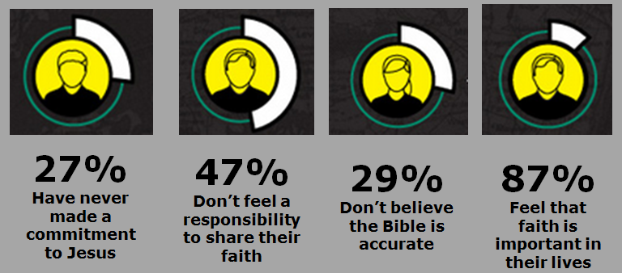
Nov 10, 2013
Worship – 10:30am
….where you will find a family of believers committed to loving you with the love of Christ. At Harvest, we glorify Jesus through teaching, prayer, equipping, worship, fellowship and outreach.

Then He said to His disciples, “The harvest is plentiful, but the workers are few. Therefore beseech the Lord of the harvest to send out workers into His harvest.“ Matthew 9:37-38

11762 Douglass St. Suites101-104, Arlington, TN 38002
www.harvestarlington.org

Tel Dan Stele Mesha Stele
Order of Worship
Gathering Time

Nursery | (birth - 3 years old) available at 10:20 am
Welcome & Announcements |  |  |  |  |  | Pastor Doug
Praise and Worship

Praise and Worship |  |  |  | Rock of Ages
 |  |  |  | Your Grace Is Enough
 |  |  |  | Mighty to Save
Children – Please retire to class |  |  |  |  |  |  | Ages PreK – 5th Grade
Prayer Time
Prayer Time |  |  | Pastor Doug
** We encourage you to use this time to post and retrieve your Prayer Card on the bulletin Board located to your left in the Sanctuary**
Message
Message – Let’s Prove |  |  |  |  | Pastor John

11.10.2013
christian fellowship
Welcome to
Let’s Prove
Showing Proof for the Bible in a World of Skepticism

People Need ___________
READ John 20:19-25

People Need ___________ _______________
Acts 17:1-4

People Need _________ _________ With _______
I Peter 3:15

