Today | FUSION Bible Study CANCELLED | 9:15am
Today | Weekly Prayer Meeting/Pastor's Bible Study | 9:15am
Today | WORSHIP SERVICE | 10:30am
Noah's Nursery (Birth-3 years of age) available @ 10:20
4 yrs old-5th graders go to their classrooms after Worship

Today | FUSION Intensity at Harvest | 5:30-7:30pm
Today | Home Groups Connect, Grow & Learn! Visit a Home Group | 5:30-7:30pm
Doug Guizlo's group at the Strelka's 12720 Rolling Lake Dr. Arlington, TN
John Horne's group is providing child care at the church for 5th grade and below.

Nov 24 | Missions Night with Matt and Star Arnold at Harvest | 5:30-7:00pm
Come and be an encouragement to missionaries Matt and Starr Arnold as they visit Harvest and share a special message.
We will have a potluck dinner from 5:30-6:00pm. Childcare (5th grade and below) will be provided from 6-7pm. Home Groups will be cancelled this evening.

Dec 6 | Camping Night - Time: TBD
Dec 13 | Christmas Caroling at Harvest | 7:00pm
 | Bring the entire family for an evening of caroling and more. We need you! The more the merrier as we sing Christmas carols to our neighbors. After singing, we will return to the church for hot chocolate, treats, and more!
Dec 24 | Christmas Eve Candlelight Communion Service/Children's Pageant at Harvest |  | 6:00-7:00pm
 | Celebrate the true meaning of Christmas with your family and your church family as we worship the birth of our Savior, Jesus Christ. We will observe Communion and see a special presentation from our children
John Horne, Pastor | john@harvestarlington.org | 489-8312
Doug Guizlo, Assoc Pastor | doug@harvestarlington.org | 378-8820
David Zachry, Worship Leader | david@harvestarlington.org | 389-0120
Jim Gentry, Business Manager | jim@harvestarlington.org | 219-3855

WANT TO GIVE TO HARVEST?
Tithes and offerings can be given at the wooden box in the rear of the sanctuary. "Each man should give what he has decided in his heart to give, not reluctantly or under compulsion, for God loves a cheerful giver." II Corinthians 9:7

Announcements

Welcome to

christian fellowship

Nov 17, 2013
Worship – 10:30am
….where you will find a family of believers committed to loving you with the love of Christ. At Harvest, we glorify Jesus through teaching, prayer, equipping, worship, fellowship and outreach.

Then He said to His disciples, “The harvest is plentiful, but the workers are few. Therefore beseech the Lord of the harvest to send out workers into His harvest.“ Matthew 9:37-38

11762 Douglass St. Suites101-104, Arlington, TN 38002
www.harvestarlington.org

Order of Worship
Gathering Time

Nursery | (birth - 3 years old) available at 10:20 am
Welcome & Announcements |  |  |  |  | Pastor Doug
Praise and Worship

Praise and Worship |  |  | Come, Now Is The Time To Worship
 |  |  | Christ Is Risen
 |  |  | Sweetly Broken
Communion

Children – Please retire to class |  |  |  |  |  | Ages PreK – 5th Grade
Prayer Time
Prayer Time |  |  | Pastor Doug
** We encourage you to use this time to post and retrieve your Prayer Card on the bulletin Board located to your left in the Sanctuary**
Message
Message – Let’s Prove |  |  |  | Pastor John

11.17.2013
christian fellowship
Welcome to

Let’s Prove (The New Testament)
Showing Proof for the Bible in a World of Skepticism

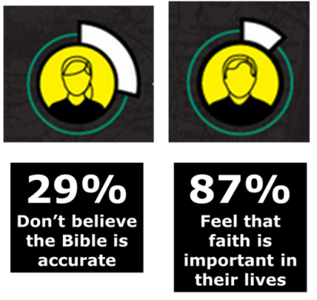
Proof…

- Brings ________________ to our Faith
- Hebrews 11:1
- II Timothy 3:14,15

Matthew 2:19-23 Proof for Mary & Joseph
John 9:8-11 Proof for the Pool of Siloam
John 11:1 Proof for Bethany (town) & Lazarus
Luke 3:1-3 Proof for Caesar Tiberius & Pontius Pilate

- Brings ___________ & Faith to our _______________.
- Romans 1:18-20

- Brings Change to the way we _____________.
- II Corinthians 5:14-15

