LIFE
ON MISSION

Our New Sermon Series
Connect●Serve●Share●Grow●Pray
Today is Part 1: CONNECT (WITH THE LOST)

- We all have a __________ to be connected.
- Connect = build a _______________.

Relational Priorities
- Connect with the Lord.
- Connect with my Spouse.
- Connect with my Family.
- Connect with my Church.
- Connect with the Lost. Pick one person!

Connecting is My Mission!
I need to connect with the __________!

- My Mission ___________.
- In the 1950’s, _____% of Americans had no religious world view.
- In 2010, ______% of Americans had no religious world view.
- My Mission ___________________. Read Acts 1:1-8
- My Mission _____________. Read Luke 19:1-10 & Matthew 9:9-12

NOTES
Our New Sermon Series
Connect●Serve●Share●Grow●Pray
Today is Part 1: CONNECT (WITH THE LOST)

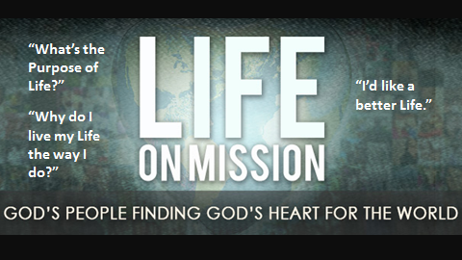
Life without Purpose (Mission?) (City Slickers) Read Quote
Value this time in your life, kids, because this is the time in your life when you still have your choices, and it goes by so quickly. When you're a teenager, you think you can do anything, and you do.
Your 20s are a blur.
Your 30s, you raise your family, you make a little money, and you think to yourself, What happened to my 30s?
Your 40s, you grow a little pot belly. You grow another chin. The music starts to get too loud, and one of your old girlfriends from high school becomes a grandmother.
Your 50s, you have a minor surgery. You'll call it a procedure, but it's a surgery.
Your 60s, you have a major surgery; the music is still loud, but it doesn't matter because you can't hear it anyway.
70s, you and the wife retire to Fort Lauderdale. You start eating dinner at 2:00, lunch around 10:00, breakfast the night before. And you spend most of your time wandering around malls looking for the ultimate in soft yogurt and muttering, "How come the kids don't call?"
By your 80s, you've had a major stroke, and you end up babbling to some Jamaican nurse who your wife can't stand but who you call mama.
Any questions?
- Mission Fail (You only had 1 job) (Slides)
- Famous Missions
WE ALL HAVE A LIFE MISSION!
- We all have a need to be connected.
- Connect = build a relationship.

Relational Priorities
- Connect with the Lord.
- Connect with my Spouse.
- Connect with my Family.
- Connect with my Church.
- Connect with the Lost. Pick one person!

Connecting is My Mission!
I need to connect with the Lost!
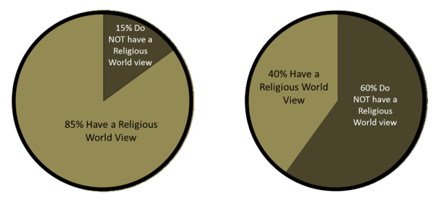
  - My Mission Need: In the 1950’s, 15% of Americans had no religious world view.
In 2010, 60% of Americans had no religious world view.

America now makes up one of the largest mission fields in the world. 195 million people don’t go to church.
The percentage of Americans who don’t claim any kind of religious worldview has gone from only 15% in the 1950s to 60% in 2010
So if 195 million people don’t go to church, and the fastest growing religious group is those who believe in nothing, I think it’s safe to say that we live in a mission field.
That pretty much sums it up, doesn’t it? So do you ever ask yourself – what is it that I’m supposed to be doing during this life that is going by way to fast?
Rick Warren says– “Why doesn't God take you to heaven the moment you become a believer? Have you ever thought about that? Why does God leave you here on earth? Now, heaven is perfect. And here there are problems and trials, sin and temptation and all kinds of stuff.

Well, there's only two things you cannot do in heaven. Ready? You can sing in heaven, pray in heaven, fellowship in heaven, serve God in heaven, lots -- rest in heaven, golf, almost everything.

There are only two things you can't do in heaven.
One of them is sin and the other is tell people the Good News about God's love.

Now, which of those two reasons do you think you're still alive for?
2. My Mission Statement (Acts 1) - IT’S A COMMAND VERB! GO DON’T STAY Being in the world but not of the world

3. My Mission Modeled
    - Luke 19:1-10
    - Matthew 9:9-12
    - DO you See me Skit?

Let me ask you something. If you're a disciple of Jesus, who is it that you're trying to be like? It's not rhetorical. It's just a simple question. If you're a disciple of Jesus, who is it you’re supposed to be like? The answer is always "Jesus;" okay? Who is it you're supposed to be like? You're supposed to be like Jesus. What did Jesus do? Jesus hung out with people who weren't church people. That's a part of discipleship.

The religious people were talking about him because he was connecting to people that didn't have God. I want to tell you something. It's probably a good sign that you look like Jesus, that you're a disciple of Jesus, when the religious people are complaining because you're around non-Christians. It's messy. The problem with sinners is they're messy. Biggest reason most churches don't mess with it, they put up their scarecrow is because they don't want the scary mess going on the inside.
How did it work out with the Matthew guy, the tax collector? He wrote the book!

SKIT- Do you recognize me?

